Clamping Diodes
Whenever the current flow through a coil is discontinued, a voltage surge or spike is produced. This spike results when electrons flowing through the coil of the relay do not want to stop and attempt to jump the open. A spark is produced if the electrons jump the open. In today’s complex electronic systems, a clamping diode is commonly used to prevent the spark. By installing a clamping diode in parallel across the coil, a bypass is provided for the electrons during the time that the circuit is open.
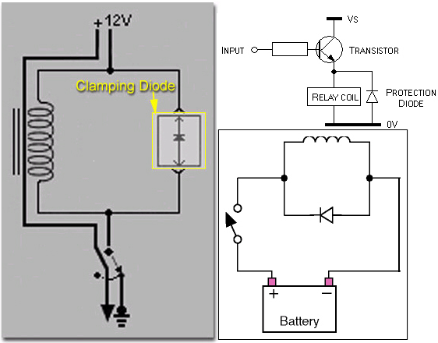
Examples of clamping diodes used in various circuits. Clamping diodes may also be called damper diodes or protection diodes.

A clamping diode is required when switching inductive loads. At turn off, the electro-motive force (EMF) creates a high voltage peak that may destroy electronics or cause line noise and/or radio frequency interference.

An example of the use of clamping diodes is on some air conditioning compressor clutches. Because the clutch operates by electromagnetism, opening of the clutch coil produces voltage spikes. If these voltage spikes were left unchecked, they would damage the vehicle’s onboard computers. The installation of the clamping diode prevents the voltage spike from reaching the computers.

